Axis of a Hollow Cylinder
# Source: AI Source: Provided by: [Data Path: Persons Table -> ID Column: 1, Name_En Column: Motasem Essam] -> From: [ChatGPT] on [7/25/2026]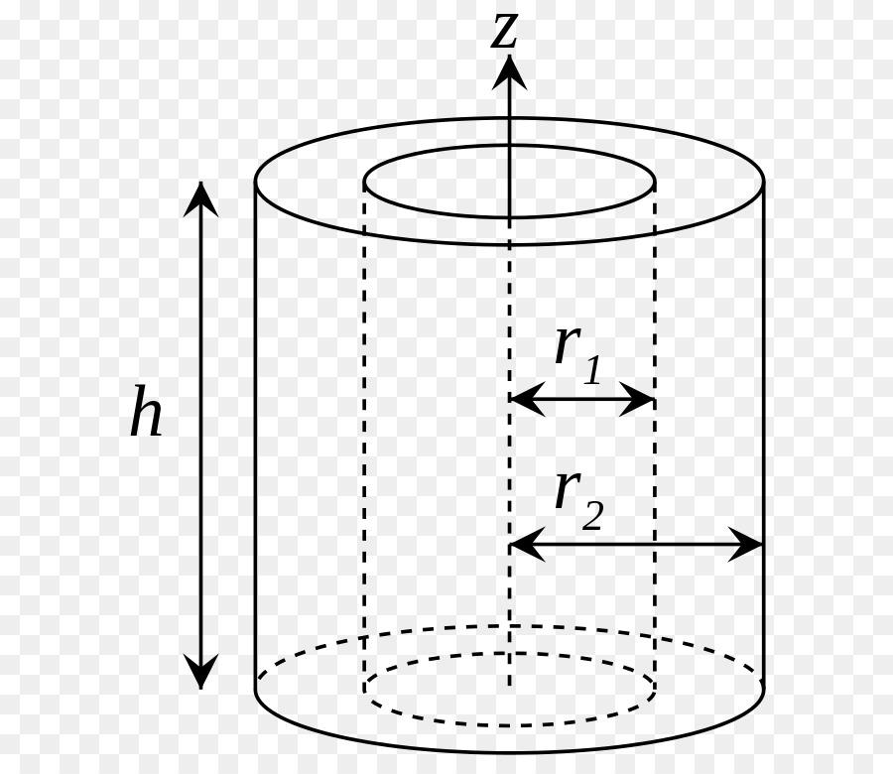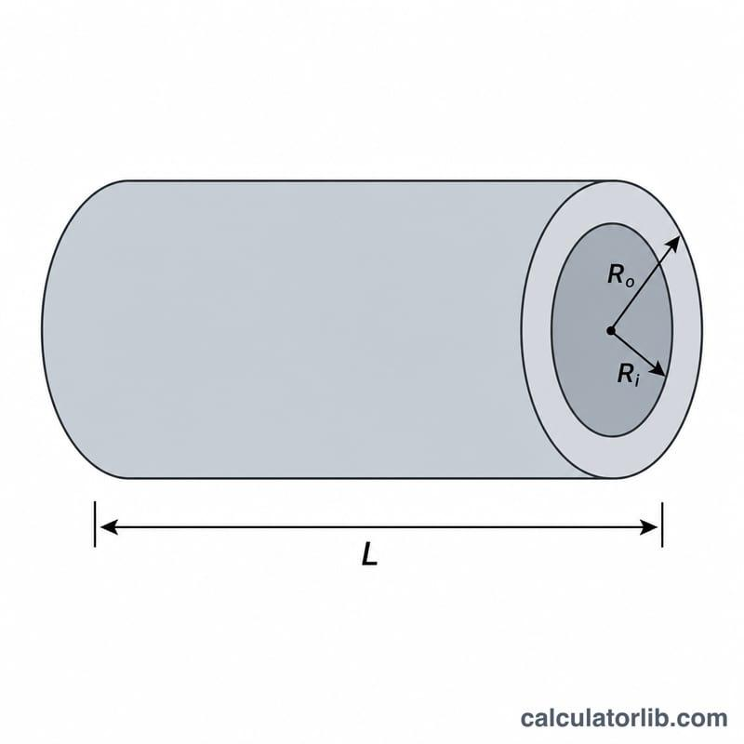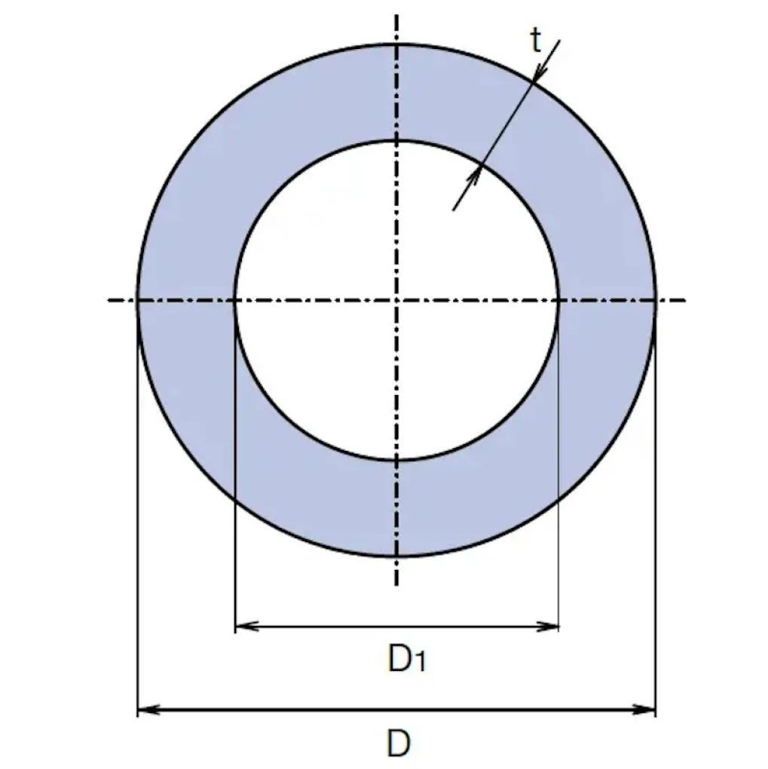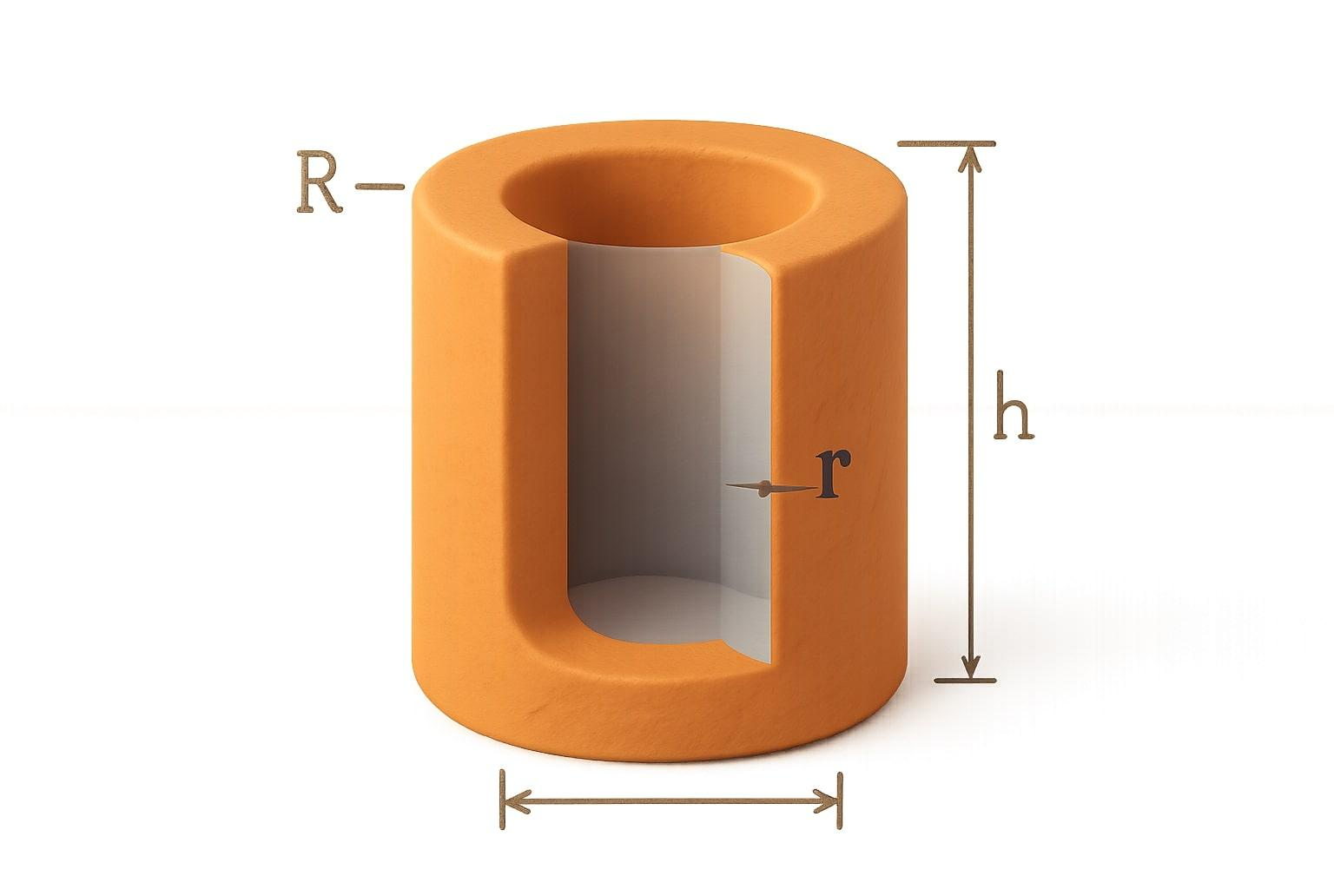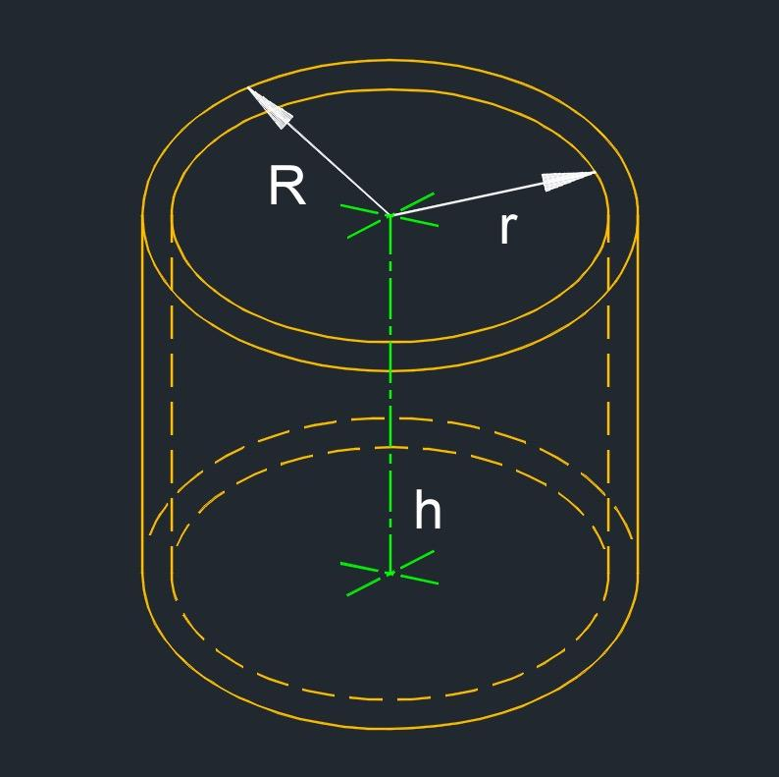

Definition
# Source: AI Source: Provided by: [Data Path: Persons Table -> ID Column: 1, Name_En Column: Motasem Essam] -> From: [ChatGPT] on [7/25/2026]
The axis of a hollow cylinder is the straight line passing through the centers of its two annular (ring-shaped) ends. It defines the cylinder's central longitudinal direction and runs through the hollow interior.
For a right hollow circular cylinder, the axis is perpendicular to the annular end faces. For an oblique hollow cylinder, the axis passes through the centers of the ends but is inclined to their planes.
- Axis: The central longitudinal line of the hollow cylinder.
- End faces: Annular regions bounded by concentric circles.
- Inner radius: $r$, the distance from the axis to the inner cylindrical surface.
- Outer radius: $R$, the distance from the axis to the outer cylindrical surface.
- Height: The perpendicular distance between the end-face planes.

Simple Definition
# Source: AI Source: Provided by: [Data Path: Persons Table -> ID Column: 1, Name_En Column: Motasem Essam] -> From: [ChatGPT] on [7/25/2026]
The axis of a hollow cylinder is the imaginary straight line running through the centers of its two ring-shaped ends and along the middle of its hollow interior.

Geometric Representation
# Source: AI Source: Provided by: [Data Path: Persons Table -> ID Column: 1, Name_En Column: Motasem Essam] -> From: [ChatGPT] on [7/25/2026]
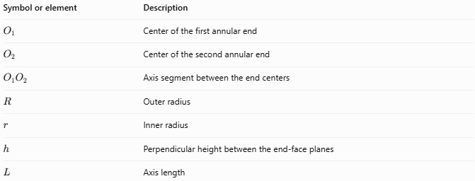
Symbol or element | Description
$$O_{1}$$ | Center of the first annular end
$$O_{2}$$ | Center of the second annular end
$$O_{1}O_{2}$$ | Axis segment between the end centers
$$R$$ | Outer radius
$$r$$ | Inner radius
$$h$$ | Perpendicular height between the end-face planes
$$L$$ | Axis length
The axis passes through the centers of both the inner and outer circles at each end because those circles are concentric.

Types and Configurations

Axis of a Right Hollow Cylinder
# Source: AI Source: Provided by: [Data Path: Persons Table -> ID Column: 1, Name_En Column: Motasem Essam] -> From: [ChatGPT] on [7/25/2026]
The axis is perpendicular to the annular end faces. Its length equals the perpendicular height.

Axis of an Oblique Hollow Cylinder
# Source: AI Source: Provided by: [Data Path: Persons Table -> ID Column: 1, Name_En Column: Motasem Essam] -> From: [ChatGPT] on [7/25/2026]
The axis is inclined to the parallel annular end faces. Its length is generally greater than the perpendicular height.
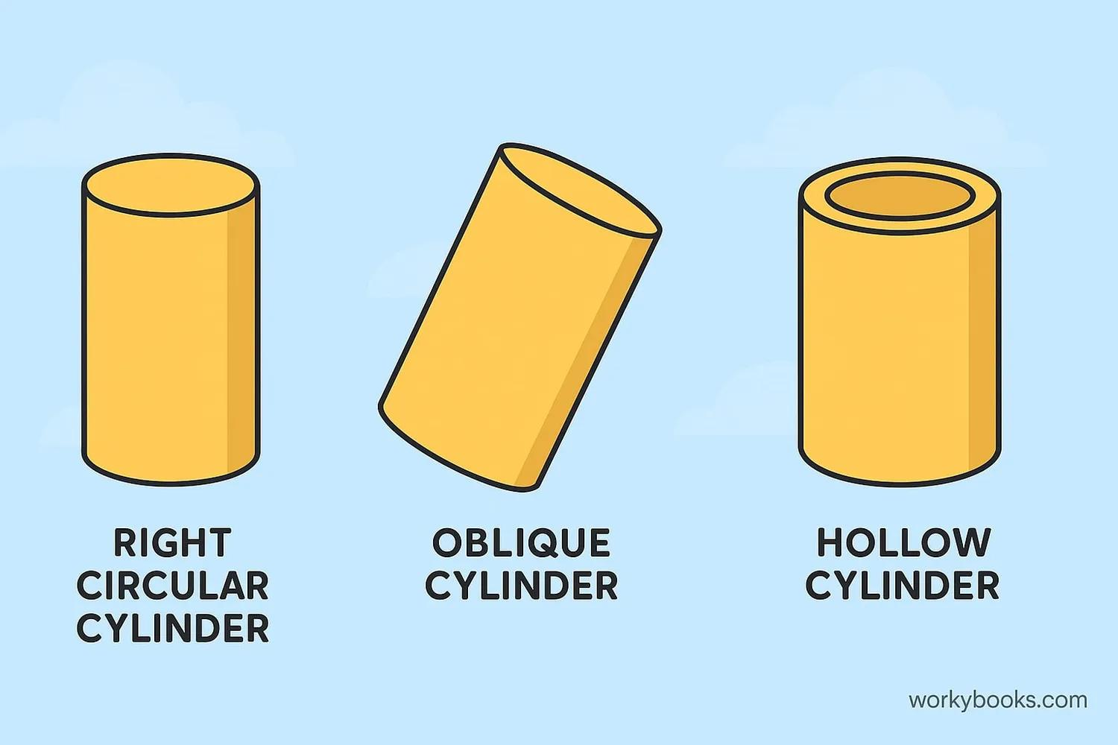

Mathematical Properties and Formulas

Axis length of a right hollow cylinder
# Source: AI Source: Provided by: [Data Path: Persons Table -> ID Column: 1, Name_En Column: Motasem Essam] -> From: [ChatGPT] on [7/25/2026]
For a right hollow cylinder:
$$\boxed{L=h}$$
where $L$ is the axis length and $h$ is the perpendicular height.

Axis length of an oblique hollow cylinder
# Source: AI Source: Provided by: [Data Path: Persons Table -> ID Column: 1, Name_En Column: Motasem Essam] -> From: [ChatGPT] on [7/25/2026]
If $θ$ is the angle between the axis and the plane of an annular end:
$$\boxed{h=Lsinθ}$$
Therefore:
$$\boxed{L=\frac{h}{sinθ}}$$

Axis length from coordinates
# Source: AI Source: Provided by: [Data Path: Persons Table -> ID Column: 1, Name_En Column: Motasem Essam] -> From: [ChatGPT] on [7/25/2026]
If the centers of the two annular ends are $O_{1}=(x_{1},y_{1},z_{1})$ and $O_{2}=(x_{2},y_{2},z_{2})$, then:
$$\boxed{L=\sqrt{(x_{2}-x_{1})^{2}+(y_{2}-y_{1})^{2}+(z_{2}-z_{1})^{2}}}$$
This formula gives the straight-line distance between the end centers.

Relationship to the hollow cylinder's dimensions
# Source: AI Source: Provided by: [Data Path: Persons Table -> ID Column: 1, Name_En Column: Motasem Essam] -> From: [ChatGPT] on [7/25/2026]
The axis is distinct from both the wall thickness and the radii:
$$Wall thickness=R-r$$
$$Outer diameter=2R$$
$$Inner diameter=2r$$
These dimensions describe the cross-section, while the axis describes the cylinder's longitudinal direction.

Worked Examples

Example 1 — Axis length of a right hollow cylinder
# Source: AI Source: Provided by: [Data Path: Persons Table -> ID Column: 1, Name_En Column: Motasem Essam] -> From: [ChatGPT] on [7/25/2026]
A right hollow cylinder has a perpendicular height of $15 cm$. Find its axis length.
Solution:
For a right hollow cylinder, the axis length equals the height.
$$L=h=15$$
$$\boxed{L=15 cm}$$

Example 2 — Axis length of an oblique hollow cylinder
# Source: AI Source: Provided by: [Data Path: Persons Table -> ID Column: 1, Name_En Column: Motasem Essam] -> From: [ChatGPT] on [7/25/2026]
An oblique hollow cylinder has a perpendicular height of $8 cm$, and its axis makes an angle of ${30}^{∘}$ with the end-face plane. Find its axis length.
Solution:
$$L=\frac{h}{sinθ}$$
$$L=\frac{8}{sin{30}^{∘}}=\frac{8}{0.5}$$
$$\boxed{L=16 cm}$$

Example 3 — Axis length from end-center coordinates
# Source: AI Source: Provided by: [Data Path: Persons Table -> ID Column: 1, Name_En Column: Motasem Essam] -> From: [ChatGPT] on [7/25/2026]
The centers of the annular ends are $O_{1}=(2,1,0)$ and $O_{2}=(2,7,8)$. Find the axis length.
Solution:
$$L=\sqrt{(2-2)^{2}+(7-1)^{2}+(8-0)^{2}}$$
$$L=\sqrt{0+36+64}=\sqrt{100}$$
$$\boxed{L=10 units}$$

Comparison with Related Concepts
# Source: AI Source: Provided by: [Data Path: Persons Table -> ID Column: 1, Name_En Column: Motasem Essam] -> From: [ChatGPT] on [7/25/2026]
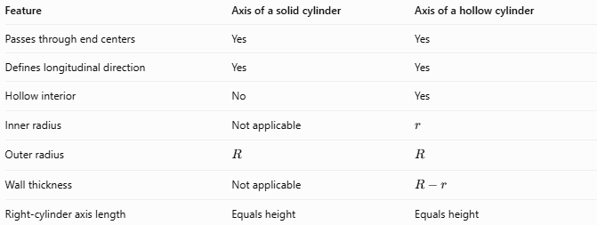
Feature | Axis of a solid cylinder | Axis of a hollow cylinder
Passes through end centers | Yes | Yes
Defines longitudinal direction | Yes | Yes
Hollow interior | No | Yes
Inner radius | Not applicable | $$r$$
Outer radius | $$R$$ | $$R$$
Wall thickness | Not applicable | $$R-r$$
Right-cylinder axis length | Equals height | Equals height
The hollow interior does not change the basic definition of the axis. The key difference is that a hollow cylinder has an inner cylindrical surface surrounding the axis.

Applications
# Source: AI Source: Provided by: [Data Path: Persons Table -> ID Column: 1, Name_En Column: Motasem Essam] -> From: [ChatGPT] on [7/25/2026]
The axis of a hollow cylinder is useful for:
- Defining the central direction of pipes and tubes.
- Aligning hollow shafts and cylindrical sleeves.
- Measuring the length of cylindrical conduits.
- Describing rotational motion around a tube's centerline.
- Establishing coordinate systems for mechanical and structural models.

Key Points
# Source: AI Source: Provided by: [Data Path: Persons Table -> ID Column: 1, Name_En Column: Motasem Essam] -> From: [ChatGPT] on [7/25/2026]
- The axis passes through the centers of both annular ends.
- The inner and outer circles at each end share the same center.
- The axis runs through the hollow interior.
- For a right hollow cylinder, axis length equals perpendicular height.
- For an oblique hollow cylinder, axis length generally exceeds perpendicular height.
- Axis length, wall thickness, inner radius, and outer radius are different measurements.

Conclusion
# Source: AI Source: Provided by: [Data Path: Persons Table -> ID Column: 1, Name_En Column: Motasem Essam] -> From: [ChatGPT] on [7/25/2026]
The axis of a hollow cylinder is the imaginary central line connecting the centers of its two ring-shaped ends. It defines the cylinder's longitudinal direction, regardless of whether the cylinder is right or oblique. The hollow interior does not alter the axis's geometric definition.

